THE POETS OF WORLD WAR I

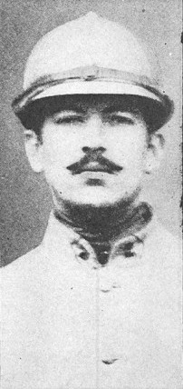
Alan Seeger (1888-1916): The only American poet in our study, Seeger lived in Greenwich Village after graduating from Harvard. There he wrote poetry and lived a bohemian life before moving to the Latin Quarter of Paris. In 1914 he joined the French Foreign Legion so he could fight for the Allies. He was eager to see combat. "I go into action," he wrote, "with the lightest of light hearts. The hard work and moments of frightful fatigue have not broken but hardened me, and I am in excellent health and spirits.... I am happy and full of excitement over the wonderful days that are ahead."
He was to be disappointed when his regiment arrived in northern France where they were sent to trenches in the center of the battle line with no prospect of open warfare. In a letter to a New York paper, he described life in the trenches:
This style of warfare is extremely modern and for the artillerymen is doubtless very interesting, but for the poor common soldier it is anything but romantic. His role is simply to dig himself a hole in the ground and to keep hidden in it as tightly as possible. Continually under the fire of the opposing batteries, he is yet never allowed to get a glimpse of the enemy. Exposed to all the dangers of war, but with none of its enthusiasms or splendid élan, he is condemned to sit like an animal in its burrow and hear the shells whistle over his head and take their little daily toll from his comrades.
The winter morning dawns with gray skies and the hoar frost on the fields. His feet are numb, his canteen frozen, but he is not allowed to make a fire. The winter night falls, with its prospect of sentry duty, and the continual apprehension of the hurried call to arms; he is not even permitted to light a candle, but must fold himself in his blanket and lie down cramped in the dirty straw to sleep as best he may. How different from the popular notion of the evening campfire,--- the songs and good cheer.
On July 4 of 1916, Seeger died at the Somme during a charge. Reportedly, he sang a patriotic song to urge his comrades on as he bled to death.
(Source: http://www.scuttlebuttsmallchow.com)

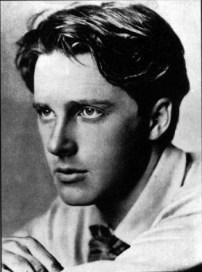
Rupert Brooke (1887-1915): Tall, handsome, and personable, Brooke became the symbol of the brave, patriotic soldier that Britain so needed in the early years of the war. As a young man, he traveled through France and Germany to recover from an unhappy love affair, returned to England where he fell in love again with an actress, sailed to America where he wrote a series of articles about his impressions of the U.S., went on to Tahiti and the South Seas (and fathered a child), and came back to Britain in 1914 shortly before war was declared. Commissioned into the Royal Navy, Brooke wrote 5 “war sonnets” that would make him famous.
In March of 1915, he embarked on a troopship for Gallipoli. In a letter, he wrote, “I’ve never been quite so happy in my life, I think. Not quite so pervasively happy; like a stream flowing entirely to one end. I suddenly realize that the ambition of my life has been—since I was two—to go on a military expedition against Constantinople.”
On board the ship, Brooke contracted “first heatstroke, then dysentery, and finally blood-poisoning. He died in April and was buried on the Greek island of Skyros. A friend, Frances Cornford, wrote a poem about Brooke that would help elevate him to the hero Britain required:
A young Apollo, golden-haired,
Stands dreaming on the verge of strife,
Magnificently unprepared
For the long littleness of life.

His most famous poetry does not reflect the horrors of war, but then, Brooke did not live long enough to experience either Gallipoli or the Western Front.

(Source: Stallworthy, Jon. Anthem for Doomed Youth. London: Constable & Robinson Ltd, 2002.)

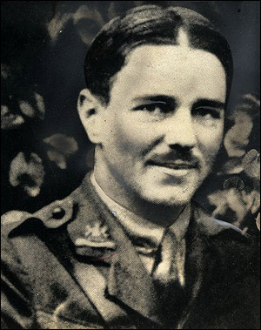 Wilfred Owen (1893-1918): Regarded by many as the epitome of the war poets, Wilfred Owen was teaching English at a Berlitz school in France when Germany invaded Belgium in 1914, and war was declared. Feeling pressured by the propaganda to become a soldier, he volunteered in October of 1915. His first month, spent in trenches, experiencing gas attacks, surrounded by the stench of dead bodies, and sleeping in freezing weather quickly showed him the reality of war. In a letter home, he said, “The people of England needn’t hope. They must agitate.”

He wrote to his mother, "I can see no excuse for deceiving you about these last four days. I have suffered seventh hell. – I have not been at the front. – I have been in front of it. – I held an advanced post, that is, a "dug-out" in the middle of No Man's Land. We had a march of three miles over shelled road, then nearly three along a flooded trench. After that we came to where the trenches had been blown flat out and had to go over the top. It was of course dark, too dark, and the ground was not mud, not sloppy mud, but an octopus of sucking clay, three, four, and five feet deep, relieved only by craters full of water .”

Later, he would fall through a shell-hole into a cellar where he was trapped for 3 days with only a candle. After two weeks in a hospital, he returned to fierce fighting and was blown out of a trench. Although he wasn’t physically hurt, a medical officer found him to be “shaky and tremulous and his memory confused.” Diagnosed with shell shock, he was sent to Craiglockhart War Hospital in Edinburgh where he would meet and become friends with Siegfried Sassoon. The older poet encouraged Owen to capture his experiences (and nightmares) in poetry. Like Sassoon, he came to believe that “All a poet can do today is warn. That is why the true poet must be truthful.”
When he returned to the Front, he did so with a conviction that he must share in the suffering of his fellow soldiers so that he could bear witness to “man’s inhumanity to man.” As the leader of an assault on a German line, he earned the Military Cross although he would not live to wear the medal. Instead he was killed when his platoon came under heavy fire as they worked to build a pontoon bridge. The date was November 4, 1918; the Armistice ending the war would take place seven days later.
In a preface to his poems about the war, published after his death, Owen wrote:
Above all I am not concerned with Poetry.
My subject is War, and the pity of War
The Poetry is in the pity.

(Sources: Stallworthy, Jon, Ed. Anthem for Doomed Youth. London: Constable & Robinson Ltd, 2002.
Stallworthy, Jon Ed. Wilfred Owen, The War Poems. London: Chatto & Windus, Ltd., 2000.)

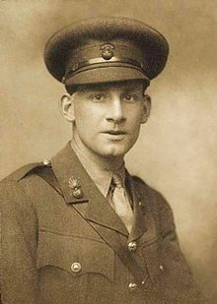
Siegfried Sassoon (1886-1967) One of the few poets who survived the war, Sassoon joined the British Army before war was declared. His first post was in France where he met Robert Graves, another poet, whose views about the need for poetry to reflect “gritty realism” would have a strong influence on Sassoon’s work.
Sassoon was renowned for his bravery, earning the Medal of Honor for his actions at the Western Front where he single-handedly captured a German trench, “scattering 60 German soldiers” with grenades among other things. In fact, his courage bordered on fool-hardiness; “he was nicknamed ‘Mad Jack’ by his me for his ear-suicidal exploits.”
However, depressed by the “horror and misery” he saw at the front and influenced by pacifist friends, he refused to return to duty following a convalescent leave. Instead, he wrote a letter to his commanding officer titled “Finished with the War; A Soldier’s Declaration,” which was forwarded to the press and read in Parliament (See excerpt below). Many considered this a treasonous action, but rather than court-martial him, Sassoon was sent to Craiglockhart War Hospital in Scotland where he was treated for shell-shock.
There he met Wilfred Owen who would eventually outshine Sassoon in recognition for his poetry. Both men returned to service in France where Owen would be killed in 1918. Sassoon would spend time in Palestine before being sent back to the Front where he was “shot in the head by a fellow British soldier who had mistaken him for a German.” He survived his wound, and spent the rest of the war in Britain.
A novel (Regeneration by Pat Barker), a movie based on the novel, and a play (Not About Heroes by Stephen MacDonald) were based on Sassoon’s life.
Excerpt from “Finished with the War; A Soldier’s Declaration”:
I am making this statement as an act of wilful defiance of military authority, because I believe that the war is being deliberately prolonged by those who have the power to end it.
I am a soldier, convinced that I am acting on behalf of soldiers. I believe that this war, upon which I entered as a war of defence and liberation, has now become a war of aggression and conquest. I believe that the purposes for which I and my fellow-soldiers entered upon this war should have been so clearly stated as to make it impossible to change them, and that, had this been done, the objects which actuated us would now be attainable by negation.
I have seen and endured the sufferings of the troops, and I can no longer be a party to prolong these sufferings for ends which I believe to be evil and unjust….
On behalf of those who are suffering now I make this protest against the deception which is being practiced on them; also I believe that I may help to destroy the callous complacence with which the majority of those at home regard the continuance of agonies which they do not share, and which they have not sufficient imagination to realize.

(Source: Stallworthy, Jon. Anthem for Doomed Youth. London: Constable & Robinson Ltd, 2002.)

